Physical Layer and Media Part 3 –

The difference between shielded twisted pair and unshielded twisted pair is the metallic shielding between each single wire. STP contains the wiring, UTP doesn’t. The color of wires does not differ as well. STP is costly than UTP because it contains metallic wires.

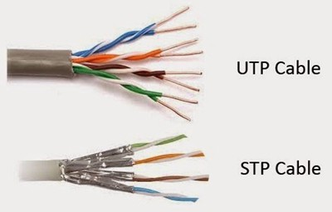

Need of metallic shielding in STP –

UTP is prone to electromagnetic interference and radio frequency interference.

The EMI and RFI acts as a barrier to the smooth data transmission, hence, need of metallic shielding is important.

Crosstalk –

The absence of the metallic shielding causes the crosstalk between the transmission of data, due to this STP is used to nullify the effect of crosstalk.

The second way of nullifying crosstalk is by increasing the twists in wire. More the number of twists in the sub wire, more the negative impact of cross talk is eliminated.

Wired media –

* Copper cable (Ethernet) – Unshielded twisted pair or Shielded twisted pair.
* Copper Coaxial Cable.
* Fiber Optic cable.

Copper Ethernet cable – One rj45 connects to the NIC card of the device such as Computers or Laptops and one connects to the switch or hub. Ethernet mostly uses the Shielded twisted pair cable.

Fiber Optic Media –

* Data is transferred as Light impulses.
* It is the fastest mode of transmission in Wired medium.

Comparison between Co-axial and fiber Optic cable –

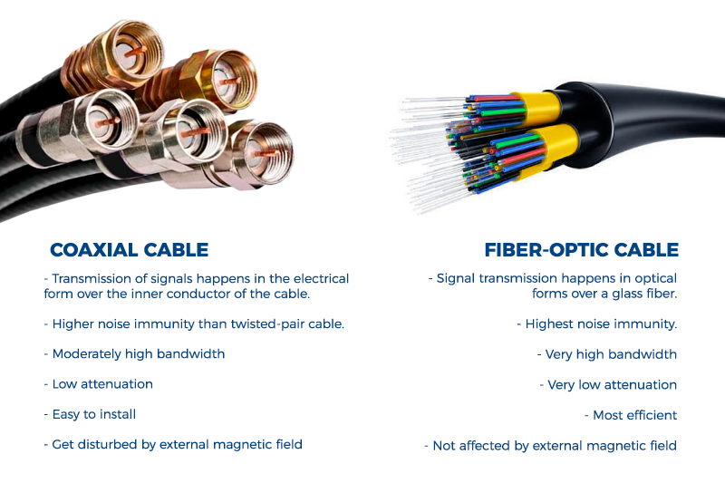

Bandwidth - 10 mbps to 10 gbps 10 mbps to 100 gbps

Range - 100 mts 100,000 mts

Immunity to - LOW Completely Immune

EMI and RFI

Immunity to - LOW Completely Immune

Elec hazards

Safety LOW HIGH

Wireless Media –

Wireless media has following areas of concern –

1. Coverage area
2. Interference
3. Security

Wireless technology –

1. WiMax
2. Zigbee
3. Wi-Fi
4. Bluetooth